**Lesson 7 Demo 5  
Docker Registry**



Steps to be followed:

1. Pulling a Linux container
2. Pushing the image to the local repository
3. Running the new image

**Step 1: Pulling a Linux container**

1.1 Pull a recent version of the Centos Linux container.

***sudo docker pull registry:2***

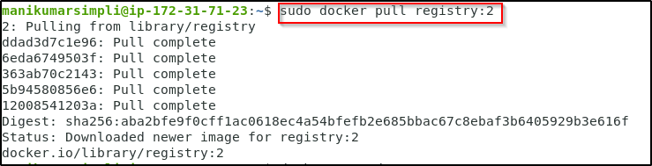

1.2 Run the registry in a new Docker container with port 5000 exposed

***sudo docker run -d -p 5000:5000 \***

***--restart=always --name registry registry:2***

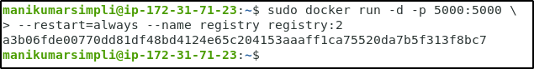

1.3 Pull another image from Docker Hub and store it in the local registry

***sudo docker pull ubuntu***

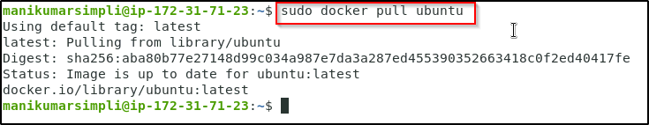

1.4 Tag the image for the local registry

***sudo docker tag ubuntu localhost:5000/ubuntu***



**Step 2: Pushing the image to the local registry**

2.1 Use the following command to push the image to a local registry:

***sudo docker push localhost:5000/ubuntu***

2.2 Remove the image from the local cache

***sudo docker rmi ubuntu***

2.3 Confirm that it has been removed

***sudo docker images***

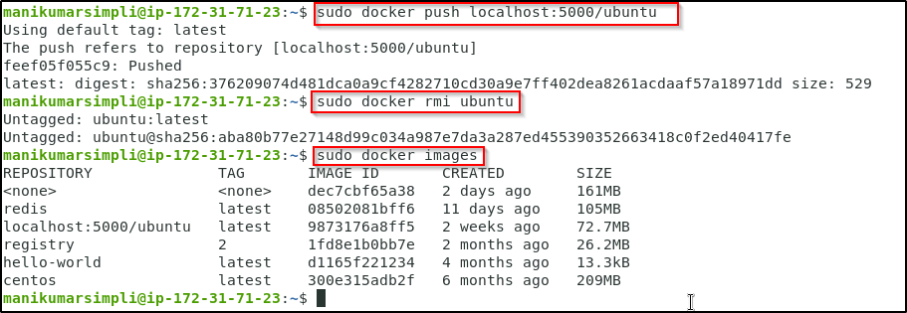

**Step 3: Running the new image**

3.1 Pull the image from the local registry

***sudo docker pull localhost:5000/ubuntu***

3.2 Confirm it is in the local cache

***sudo docker images***

3.3 Run the new image

***sudo docker run -it --rm localhost:5000/ubuntu /bin/bash***

3.4 Exit the container

***exit***

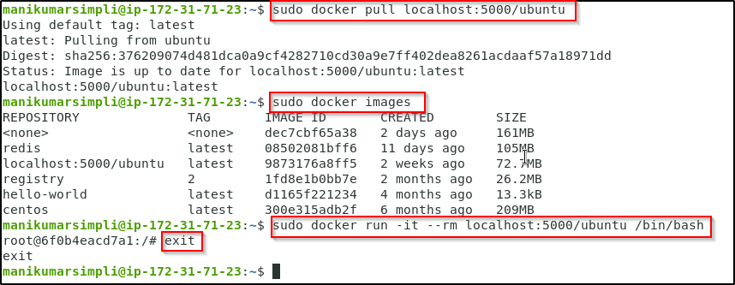

3.5 Clean up the images and containers

***sudo docker rm -f $(docker ps -aq)***

**Note:** In case you get a permission denied error as shown below, run the following

***sudo chmod 666 /var/run/docker.sock***

After running this, run the ***sudo docker rm -f $(docker ps -aq)*** command.

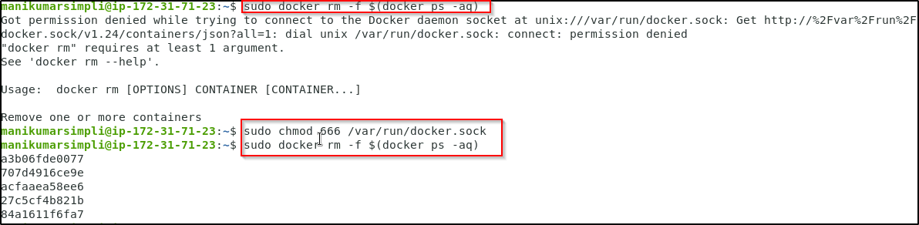

***sudo docker rmi $(docker images -q)***

